Eyeconic - Glasses Shop Management System

M30 - Remove Categories

Version 1.0

Revision History

|  |  |  |  |
| --- | --- | --- | --- |
| **Date** | **Version** | **Description** | **Author** |
| 05/11/2019 | 1.0 | Start creating use case | Hoàng Tiến Long |
|  |  |  |  |
|  |  |  |  |
|  |  |  |  |

Table of Contents

1. Remove Categories 4

1.1 Brief Description 4

1.2 Actor 4

2. Flow of Events 4

2.1 Basic Flow 4

2.2 Exception 4

2.2.1 Remove category 4

3. Special Requirements 4

4. Preconditions 4

4.1 Login 4

5. Postconditions 5

6. Extension Points 5

Use-Case Specification: Remove Categories

# Remove Categories

## Brief Description

This use cacse defines the step of delting category.

Categories are deleted by the admin.

## Actor

Administrator.

# Flow of Events

## Basic Flow

In categories management, the system administration clicks the remove button management category. The confirmation dialog show case. The system displays the updated management parameter value and logs the change.

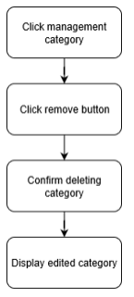

***Basic flow of removing order***

Step 1: Click management category.

Step 2: Click remove button.

Step 3: Confirm removing new category.

Step 4: Display edited category.

## Exception

### Remove category

The remove button cannot be clicked or isn’t appeared on the screen.

# Special Requirements

No Special Requirements

# Preconditions

## Login

Actor must already login as the administrator of the website

Accuracy is required when administrator want to remove category.

# Postconditions

# Extension Points

No extension points.